Module 2: Case Study-

AWS Solutions Architect Training
Problem Statement: You work for XYZ Corporation. Your corporation is working on an application, and they require secured web servers on Linux to launch the application.
Tasks To Be Performed:
1. Create an instance in the US-East-1 (N. Virginia) region with Linux OS and manage the requirement of web servers of your company using AMI.
2. Replicate the instance in the US-West-2 (Oregon) region.
3. Build two EBS volumes and attach them to the instance in the US-East-1 (N. Virginia) region.
4. Delete one volume after detaching it and extend the size of the other volume.
5. Take backup of this EBS volume

Task 1: Create an instance in the US-East-1 (N. Virginia) region with Linux OS and manage the requirement of web servers of your company using AMI.

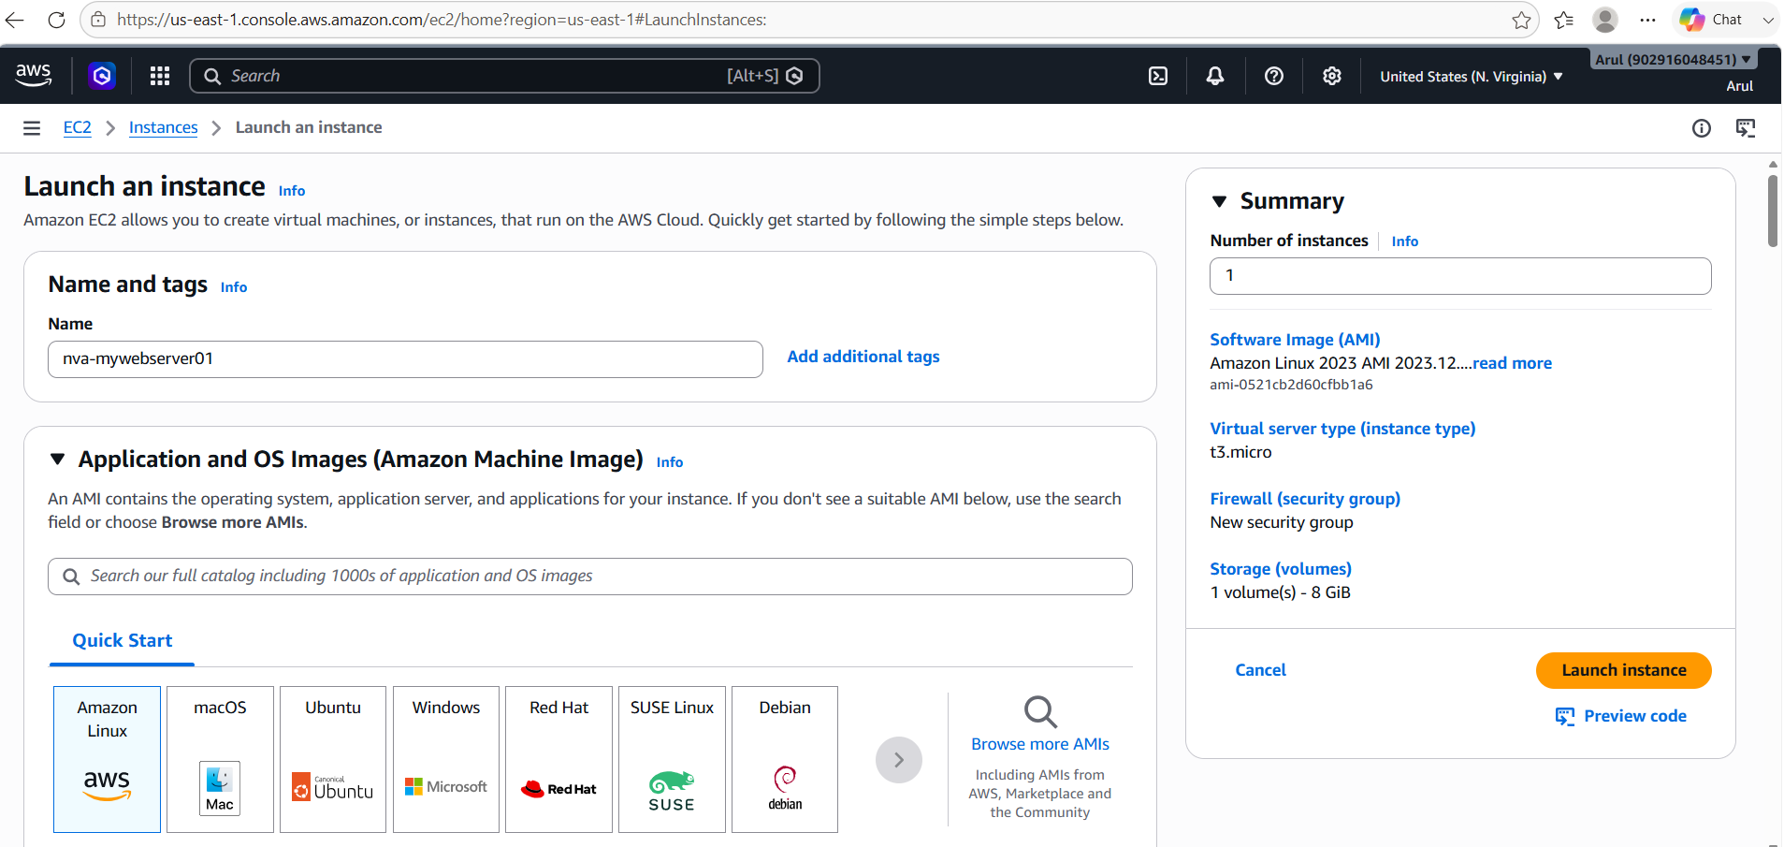
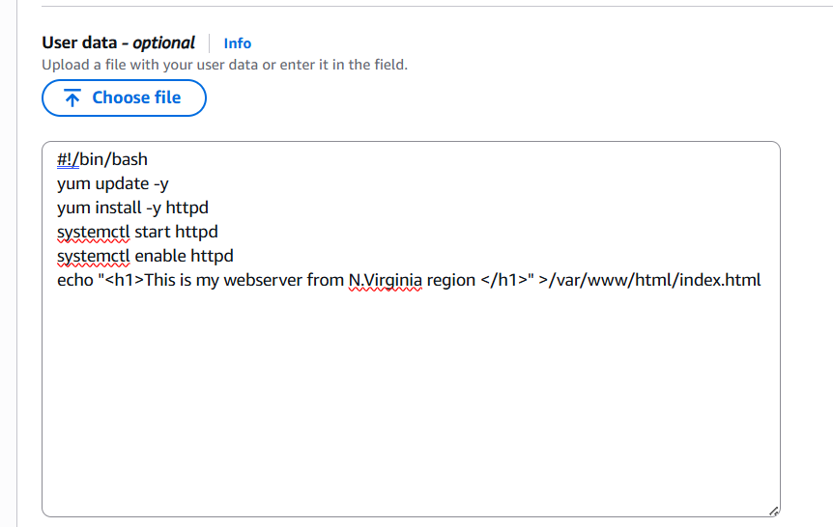

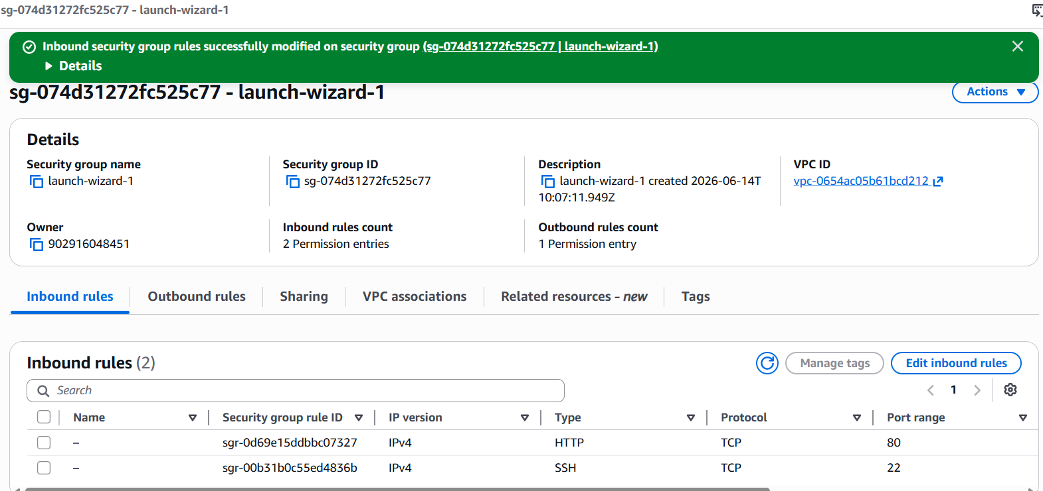

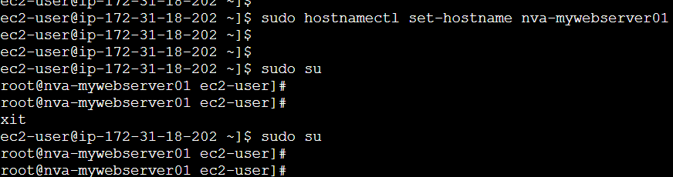

Website output:

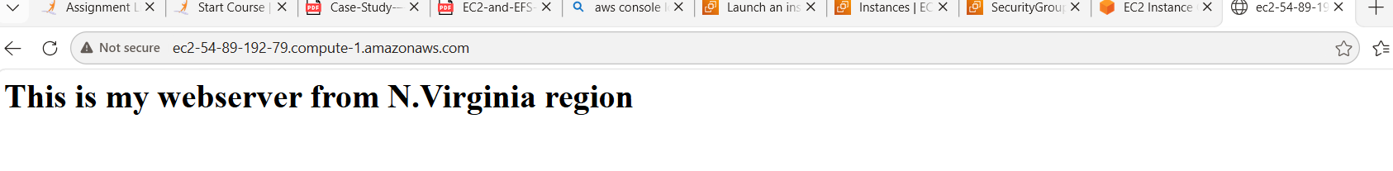

Task 2: Replicate the instance in the US-West-2 (Oregon) region.
Create an AMI from the EC2 instance:
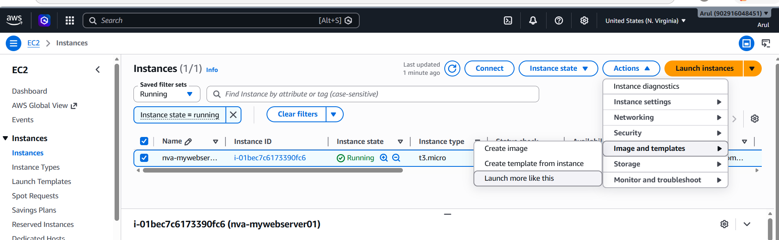
Source AMI ID: ami-09d596a78718e2815
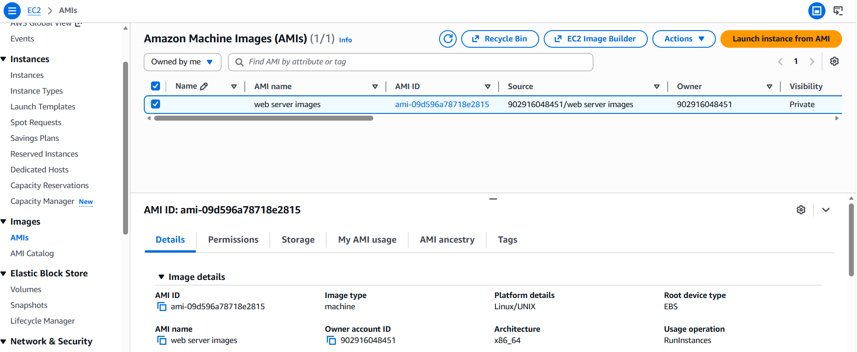

Copy the AMI to Oregon:
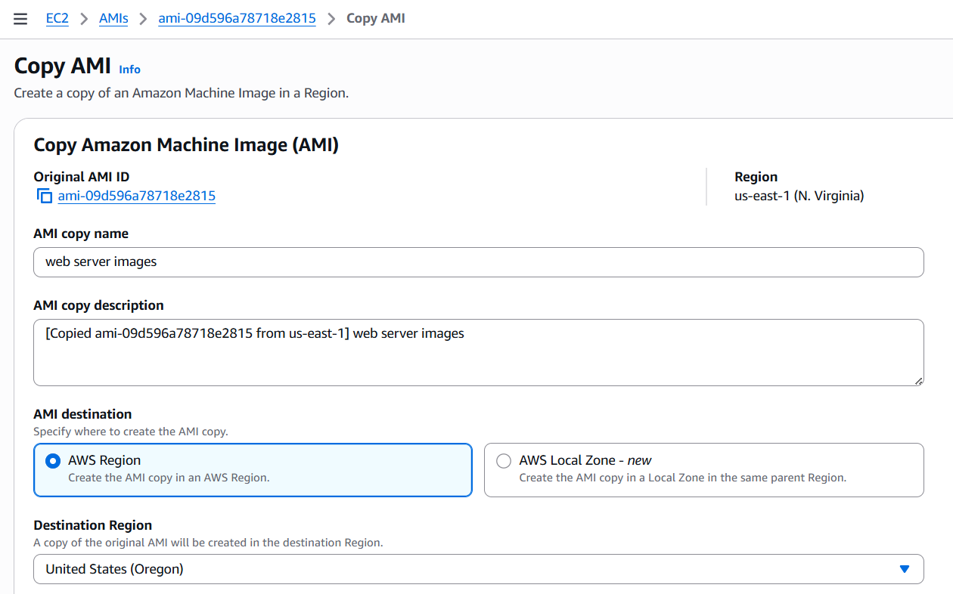

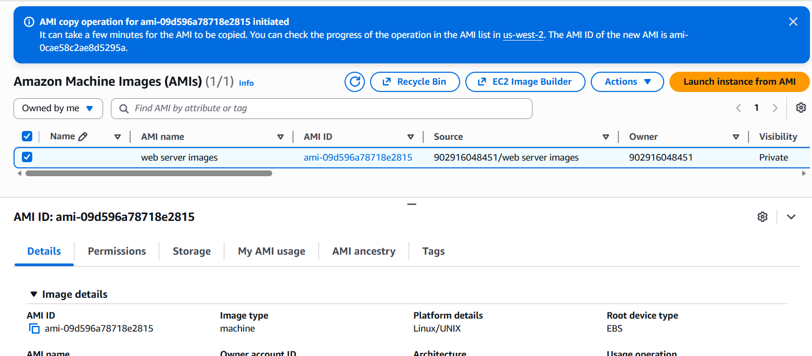

Destination Image: ami-0cae58c2ae8d5295a
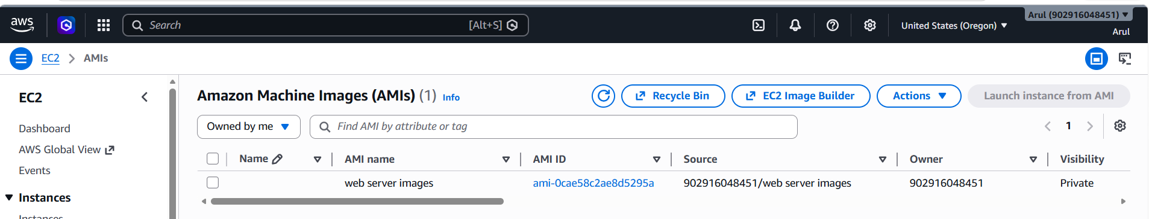

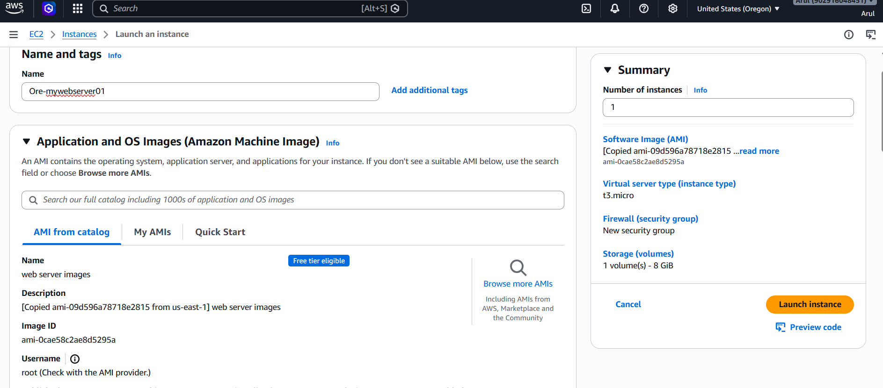

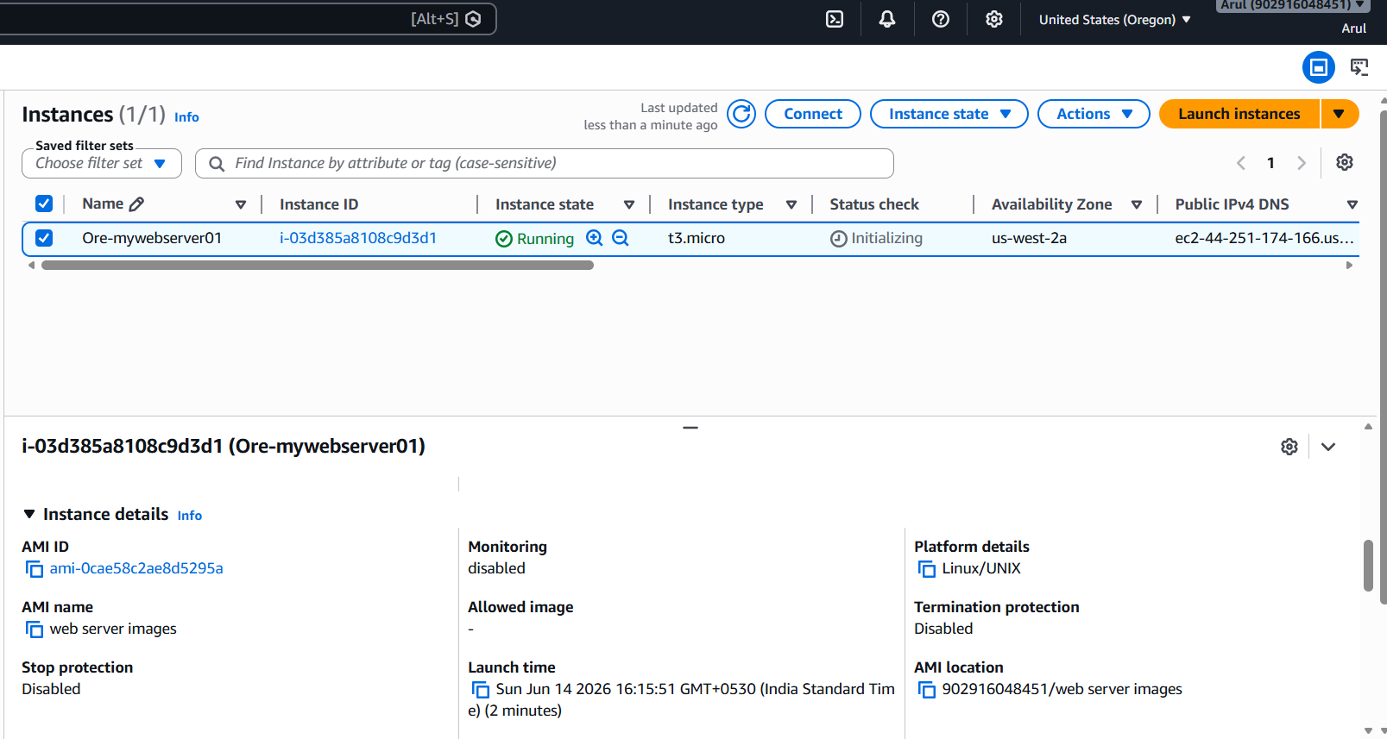

Changing the web output:
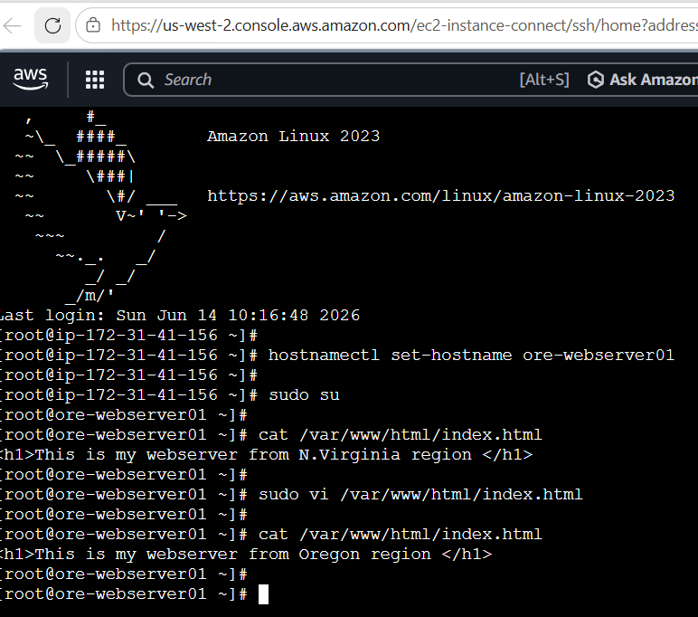
Enabling http port:
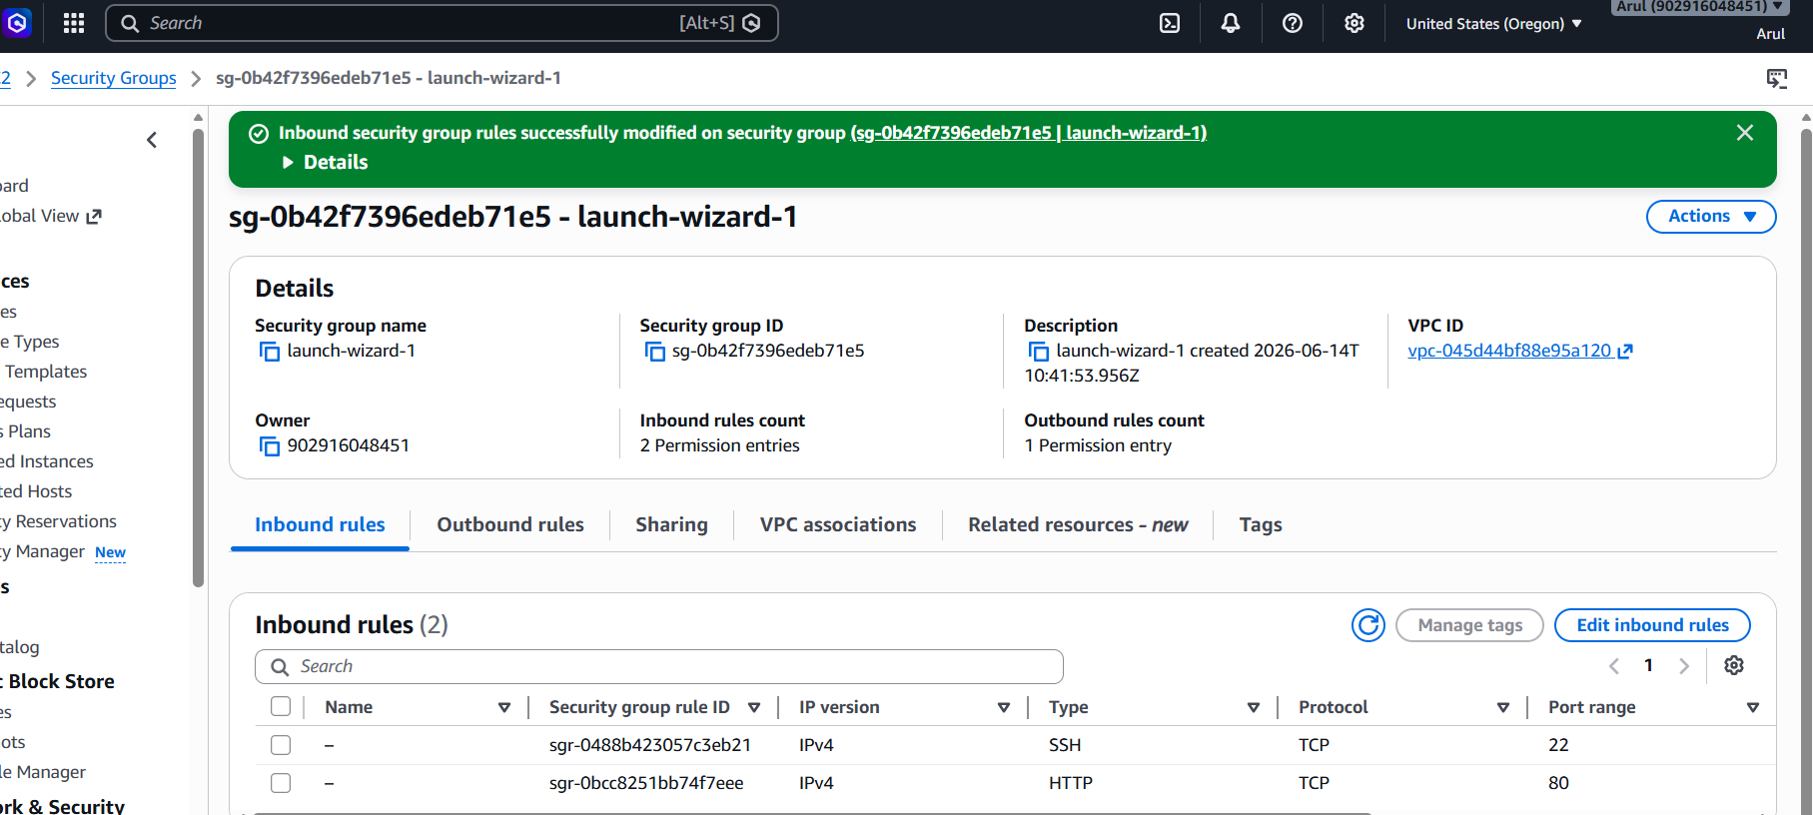

Website output:
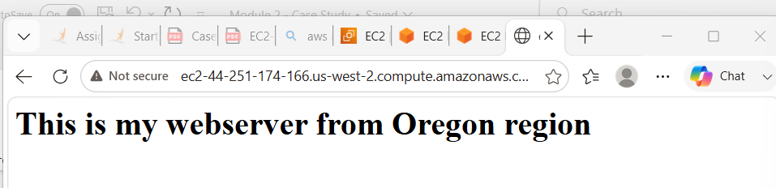

Task 3. Build two EBS volumes and attach them to the instance in the US-East-1 (N. Virginia) region.

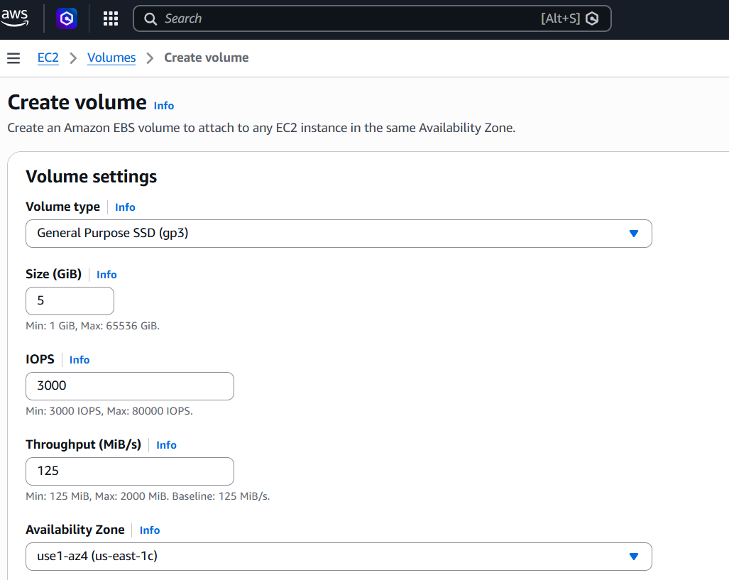

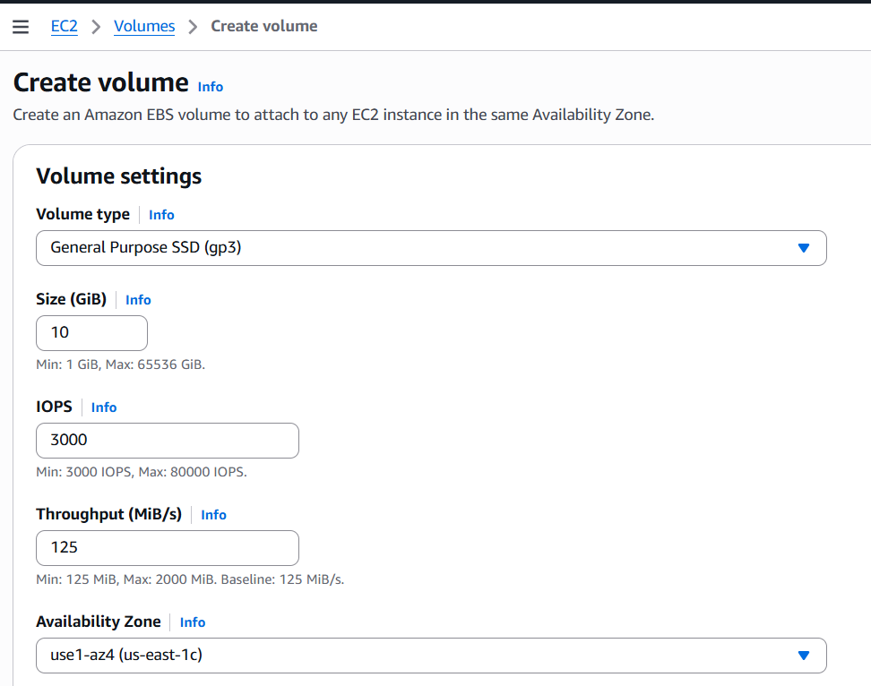

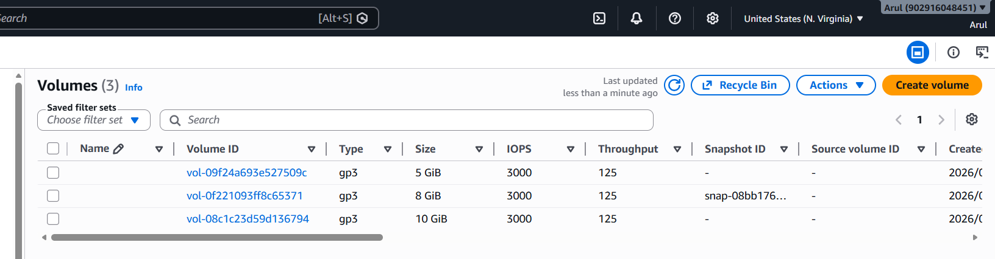

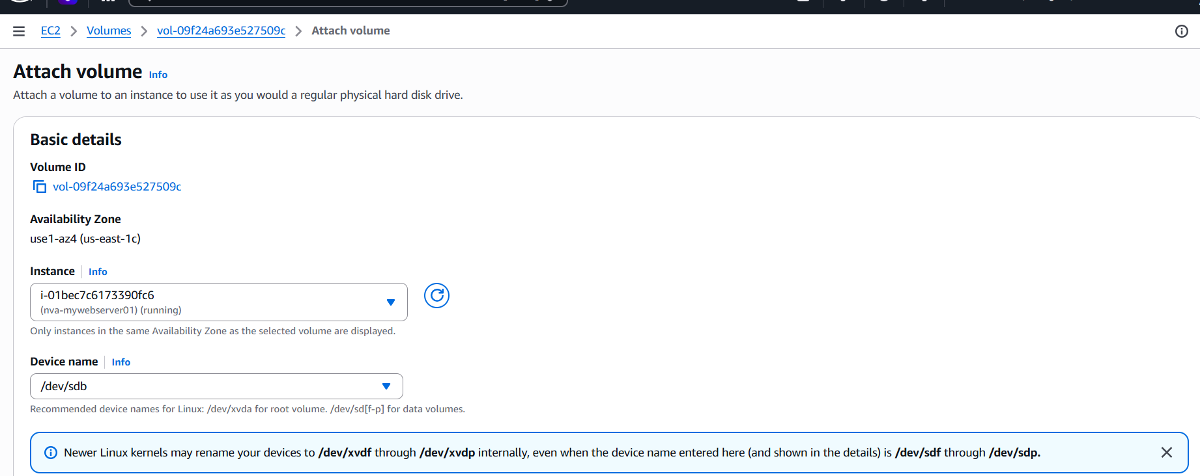

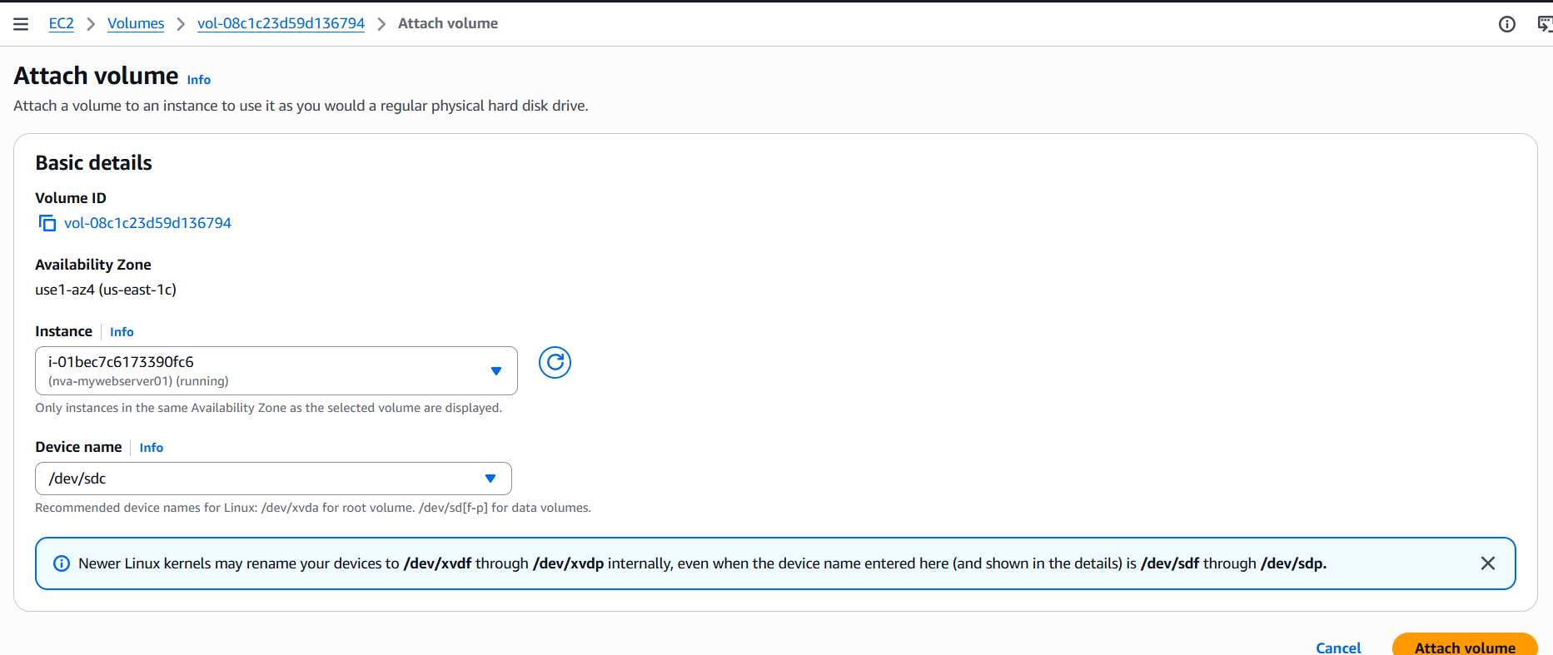

Attached to the server:
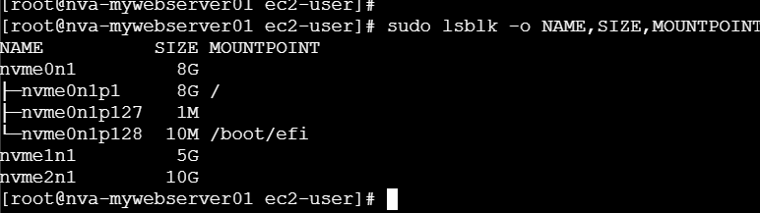

Task 4. Delete one volume after detaching it and extend the size of the other volume.

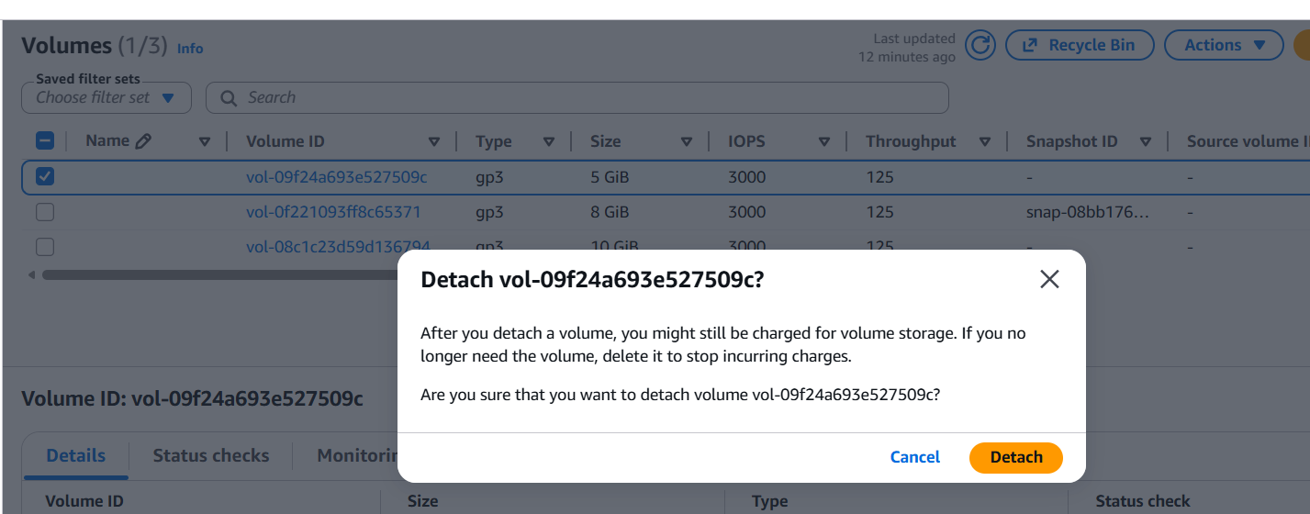

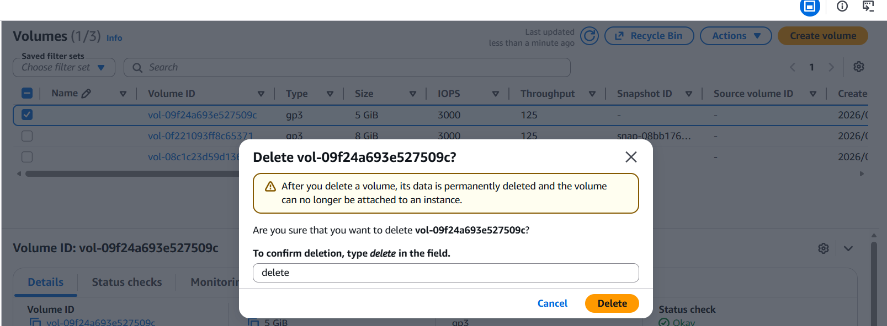

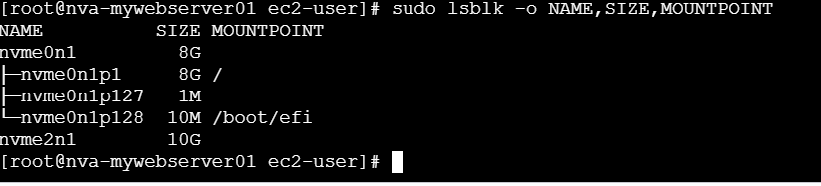

Extending 10G on volume vol-08c1c23d59d136794:
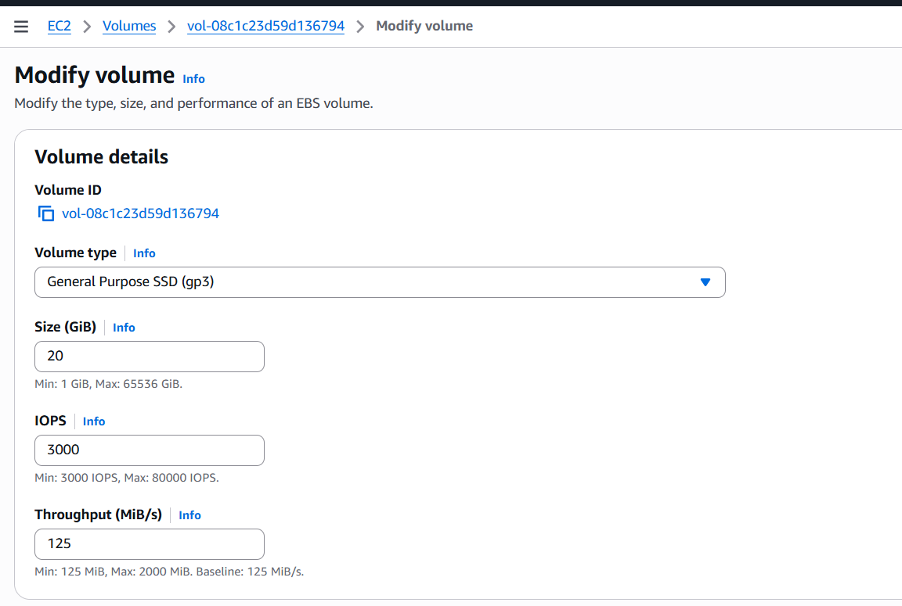

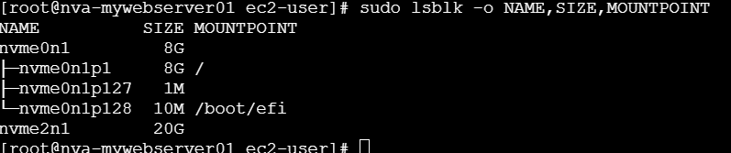

5. Take backup of this EBS volume - vol-08c1c23d59d136794:

